**FPT ACADEMY INTERNATIONAL**

**FPT – APTECH COMPUTER EDUCATION**



**Centre Name: ACE-HCMC-2-FPT.**

**Address: 590 Cach Mang Thang 8, District 3, Ho Chi Minh City, Viet Nam.**

**GIFTS ONLINE**

|  |  |  |
| --- | --- | --- |
| **Supervisor** | PHAM THI LANH | |
| **Semester** | 1 | |
| **Batch No** | T1.2008.M0 | |
| **Group No** | 8 | |
| **Order** | **Full name** | **Roll No.** |
| 1. | NGUYEN SON NGOC | Student1273498 |
| 2. | NGUYEN ANH TAI | Student1270670 |
| 3. | NGUYEN TRUONG THINH | Student1273004 |
| 4. | NGUYEN XUAN DUC | Student1273002 |



Month 10 Year 2020



This is to certify that

Mr: Nguyen Son Ngoc

Mr: Nguyen Anh Tai

Mr: Nguyen Truong Thinh

Mr: Nguyen Xuan Duc

Has successfully Designed & Developed

**GIFTS ONLINE**

Submitted by:

Pham Thi Lanh

Date of issue:

October, 23rd 2020

Authorized Signature:

Contents

Objectives of the project 4

Problem Statement 5

REVIEW 1 6

REQUIREMENT SPECIFICATION 7

CUSTOMERS REQUIREMENT SPECIFICATIONS (CRS) 8

ARCHITECTURE & DESIGN OF THE SYSTEM 9

SITEMAP 10

WEBSITE LAYOUTS 11

1. Homepage: 11

2. Informative pages: 13

TASK SHEET 1 14

# Objectives of the project

The Objective of this program is to give a sample project to work on real life projects. These applications help you build a larger more robust application.

The objective is not to teach you JavaScript/Dreamweaver but to provide you with a real life scenario and help you create basic applications using the tools.

You can revise the chapters before you start with the project.

This project is meant for students who have completed the module of ***HTML5***. These programs should be done in the Lab sessions with assistance of the faculty if required.

It is very essential that a student has a clear understanding of the subject. Students should go through the project and solve the assignments as per requirements given.

Kindly get back to eProjects Team in case of any doubts regarding the application or its objectives.

# Problem Statement

GIFTS ONLINE is selling various types of Gift Items. The company advertises by distributing the pamphlets, advertising on television and so on. Due to rapid development in internet field, the company decides to launch a website where people will get all the information about the various products available with them easily.

You are supposed to create a website for them with the below mentioned requirement specifications.

The website is to be developed for the Windows Platform using HTML5, JavaScript and Geolocation. The site should work well in all leading browsers including Chrome, IE, Firefox etc.

# REVIEW 1

# REQUIREMENT SPECIFICATION

**The Web site is to be created based on the following requirements.**

1. The Home Page should be created making use of Frames with a suitable logo.
2. Home Page should contain details of Gift Items with suitable images.
3. The site should display a menu which will contain the options for brief introduction about the various gift items available, location of the shop and any other information if required.
4. The information about products should be presented in two ways:
   * + - 1. Information should be available category wise, wherein user can click on a particular category and should be able to view all the products related to the category available with complete information. Eg. Category can be “Mugs”, “Cards”, Bracelets” etc. with suitable sub-categories been defined.
         2. Information should be categorized according to the brand names of the products like if a User wants to see only “Hallmark” products or any other company’s products then he/she can click on a Link/button/menu etc and can see only that Brand products.
5. When a user selects any particular brand, a list of products for that brand will be displayed
6. A brief summary of features of individual products should be displayed on the Web Page along with the product but detailed Features should be stored in Individual Word documents which can be downloaded or viewed by the User who wishes to see the same.
7. The user should also be able to compare the various products of different as well as similar brands.
8. There should be a “Contact Us” page which will have the Address of the Company which is as follows and the mail address which when clicked will invoke the local mail client from where they can send an email. Address of the Company should be displayed using GeoLocation API (eg. GoogleMaps).

# CUSTOMERS REQUIREMENT SPECIFICATIONS (CRS)

**1.Client: GIFTS ONLINE**

**2.Business/Project Objectives:**

Provide a website to displays the programs and services about gift shop such as: “Favorites”, “Sale”, “Best Seller”, “Cart”, “About Us”, “Feedback”…

Enable customers to see what event that they would like. Easier interactive with us.

**3.Hardware Requirement:**

* A minimum computer system that will help you access all the tools in the courses is a Pentium 166 or better
* 64 Megabytes of RAM or better

**4.Software Requirements:**

* Notepad/HTML editor
* Dreamweaver
* IE 5.0/ Netscape 6.0

# ARCHITECTURE & DESIGN OF THE SYSTEM

**CLIENT**

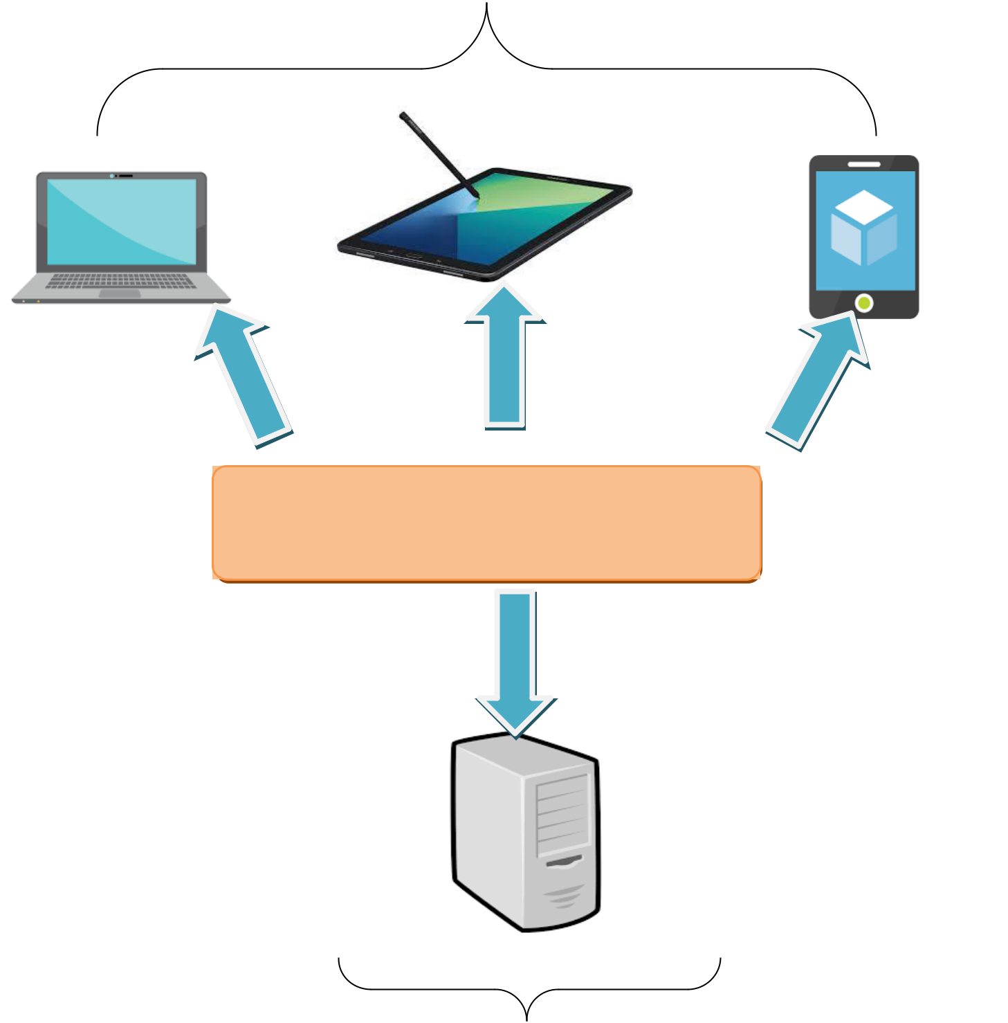

Font End technologies

(HTML5, CSS3, Bootstrap, jQuery)

**SERVER**

# SITEMAP

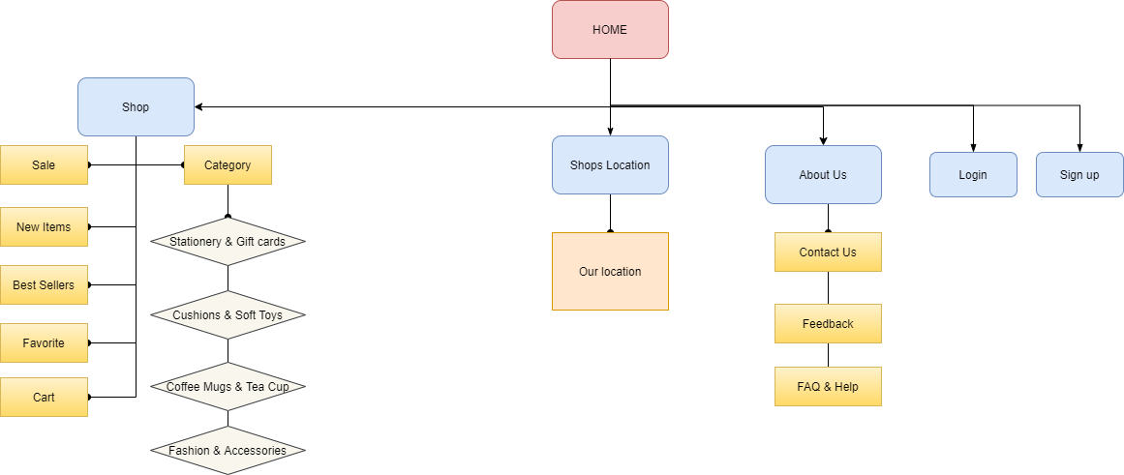

# WEBSITE LAYOUTS

**Here are our layouts which will show you how we brainstormed ideas for the Gift shop’s web pages. Because of being Gift shop website, we tried to build them DYNAMIC, COMFY and INFORMATIVE as much as possible.**

**The website is going to have several pages which include different information and products in the same main layout.**

## **1. Homepage:**

This layout below describes how we created our Homepage which contain three important parts:

* *Page-header and Navigation bar:*

Page-header must have gift shop’s logo and other links like contact us, shop, login, sign up. Search gifts bar is optional.

Navigation bar is one of the most crucial sections in the whole website which will indicate people how they interact with us. It provide some information like Shop, Shops location, About Us, Login, Sign up, Favorite, Cart, etc... Each section must have brief information.

* *Content:*

This section is customized according to the title of each website, the Home page will display some typical products of Gifts Online and optional features of each product.

* *Footer:*

The last part of all our websites is undoubtedly Footer which will reveal some convenient ways to contact your shop on various social channels like Phone, Email, Facebook, Twitter as well as display the address and location of our shop.

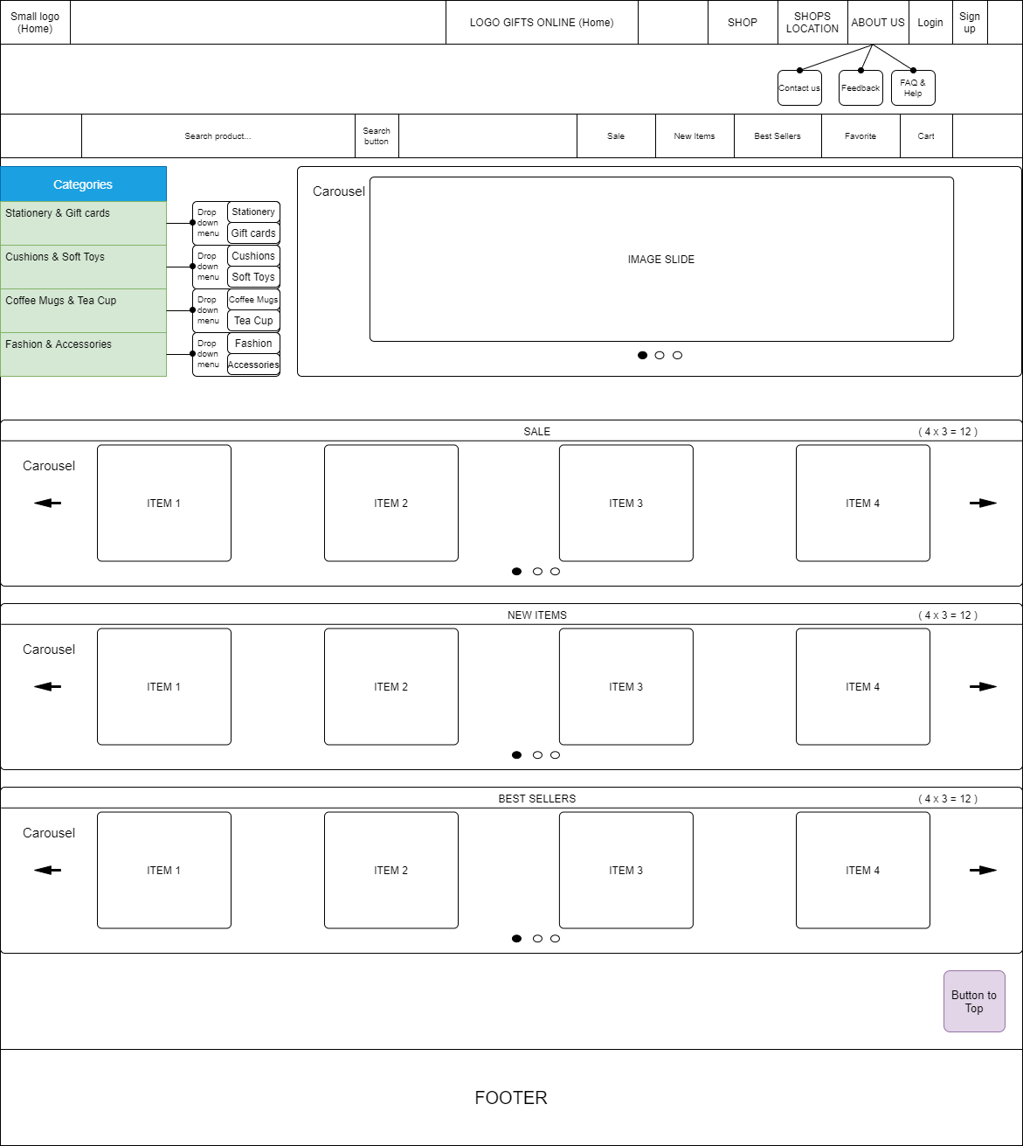

## **2. Informative pages:**

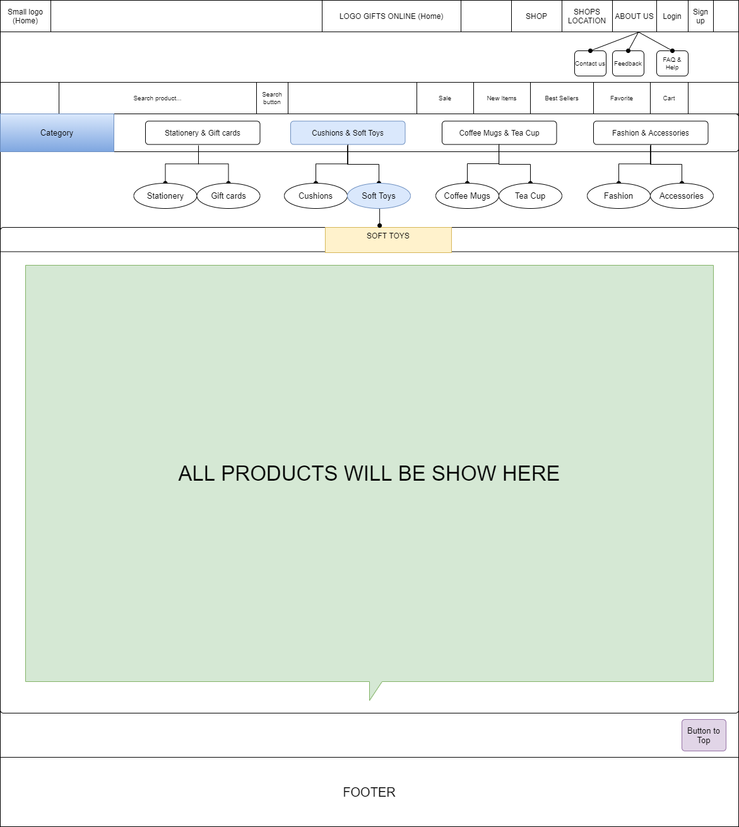This layout we will apply for most of other pages (About Us, Feedback, FAQ & Help...) which provide people different information about the Cambridge hospital. It also has the same Page-header, Navigation bar and Footer as Homepage, but the main content is changed. Interestingly, we will change design “Category” bar with class “active” to help people enter another related website easier.

# TASK SHEET 1

|  |  |  |  |  |  |  |
| --- | --- | --- | --- | --- | --- | --- |
| **Project Ref. No.** | **Project Title** | **Activity Plan Prepared by** | **Date of Preparation of Activity Plan** | | | |
| **Task** | **Actual Start Date** | **Actual Days** | **Teammate Names** | **Status** |
| **Create layouts for website base on group discussion ideas** | GIFT ONLINE | Ngoc | 15/10/2020 | 2 | Ngoc  Tai  Thinh | Completed |
| **Draw layouts using Paint** | GIFT ONLINE | Ngoc | 17/10/2020 | 3 | Ngoc  Tai | Completed |
| **Write project report 1** | GIFT ONLINE | Ngoc | 16/10/2020 | 3 | Ngoc | Completed |
| **Homepage design and coding (include navigation bar and footer)** | GIFT ONLINE | Ngoc  Tai | 18/10/2020 | 4 | Ngoc  Tai  Thinh | Completed |

|  |  |
| --- | --- |
| Signature of Faculty | Signature of Leader Team |
|  |  |
|  |  |